**Vivek Pandey**



**About Me**

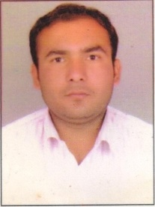­­



Pvivek8819@gmail.com



+91-7089942338



5 Years experience



BE (Computer Science Engg.)



Rewa, Madhya Pradesh

Desirous of an IT Service Management role in a challenging workplace that welcomes innovative ideas and offers growth opportunities and positive environment for accomplishing projects.



**Work Experience**

|  |  |  |  |
| --- | --- | --- | --- |
| **Company Name** | **Period** | **Field of work** | **Year** |
| VeServ | 3 years | Team lead, System S/w  H/w Management, IT Services | 2017 |
| Suma Soft | 7 Months | Customer Data Handling | 2017 |
| Sonata Finance Pvt. Ltd. | 1 Yr | Capital Management. | 2016 |
| Vision India | 8 Months | Team Leader (Handling ERC Service) | 2018 |



**Education**

|  |  |  |  |  |
| --- | --- | --- | --- | --- |
| **Examination** | **University** | **Institute** | **Year** | **%** |
| B.E. | RGPV Bhopal | Rewa Institute of Technology | 2017 | 74.60% |
| Diploma in Information Technology | RGPV Bhopal | Government Polytechnic College Khargoan | 2011 | 65.66% |
| High Secondary(VOCC) | MPBSE | Government Martand  H. S. School No 1 Rewa | 2008 | 73.72 |
| High School | MPBSE | Government H. S.  School No 1 Rewa | 2006 | 59.70% |



**Skills**

* System Hardware Management.
* SEO
* Utility Software: MS Office Suite (Excel, Word, Power point)., Tally, Photoshop
* OS: WINDOWS Server & 7/8/10 & Linux Server.



**Languages**

* Hindi
* English



**Personal Interests**

|  |  |
| --- | --- |
| * Foodie. |  |
| * Travelling. * BasketBall(State-Level) * NCC(A –Certificate Rank CQMS) |  |
|  |  |



**Personal Details**

|  |  |
| --- | --- |
| DOB | 9 Feb 1989 |
| S/O | Vijay Pandey and Anandi Pandey |
| Address | 53 Amwa via Beena Rewa Madhya Pradesh |

**Declaration**

I hereby declare that the information contained here is true and correct to the best of my knowledge and belief.

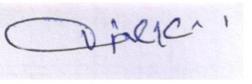

____________________________  
Vivek Pandey Bhopal, Madhya Pradesh